Report

Q. 1) Find all the unique 'Wind Speed' values in the data.

A. Below is the code to find all the unique Wind Speed values in the data:

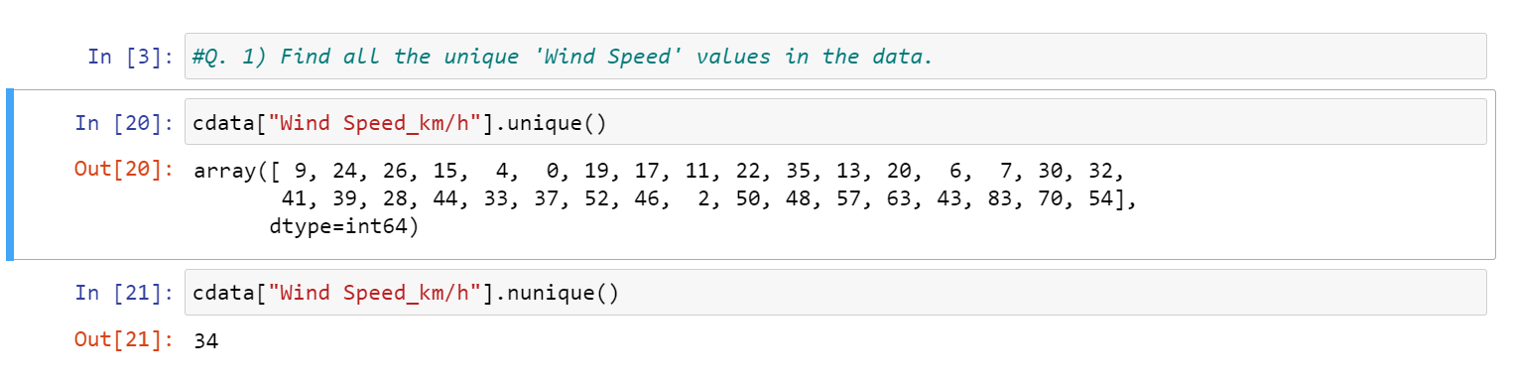

* First we have to access Wind Speed column, we used unique () and nunique() functions to get the unique wind speed values.
* From the above result, we got array of 34 unique values for wind speed in the given data. Here, the least wind speed is 0 and the highest wind speed is 83.

Q. 2) Find the number of times when the ‘Weather is exactly Clear’.

A. To find the no of times the weather is exactly clear, here is the code:

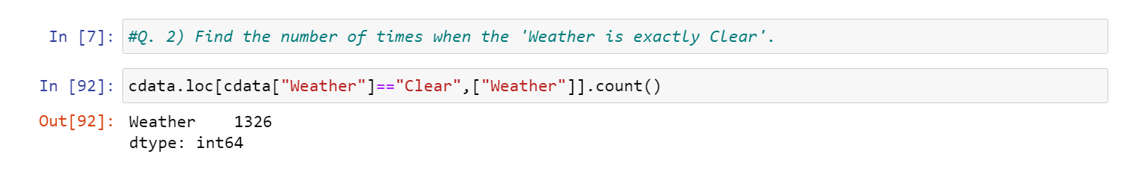

* We used loc function and count() function to get number of times weather is exactly clear.
* Out of 8784 number of times, 1326 times the weather is exactly clear.

Q. 3) Find the number of times when the ‘Wind Speed was exactly 4 km/h’.

A. Here is the code to find the no of times when the wind speed was exactly 4 km/h:

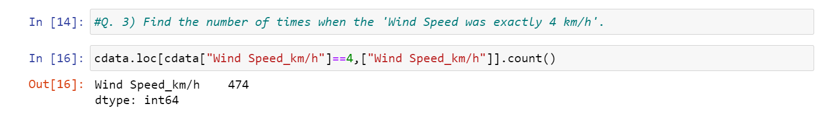

* Here loc function and count() function are used to find the number of times the wind speed was exactly 4 km/h
* From the output, we can say 474 times the wind speed was exactly 4 km/h.

Q. 4) Find out all the Null Values in the data.

A. To find out the null values in the data, below is the code:

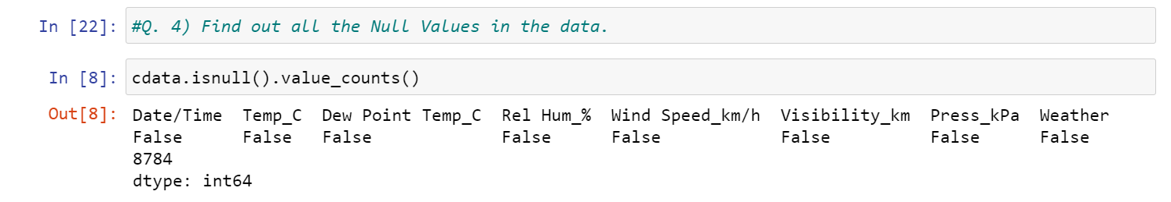

* By using isnull() function and value_counts() function, we find we we have null values in the data or not.
* In this data, null values are not present.

Q. 5) Rename the column name 'Weather' of the dataframe to 'Weather Condition'.

A. To rename the column name Weather to Weather Condition, below is the code:

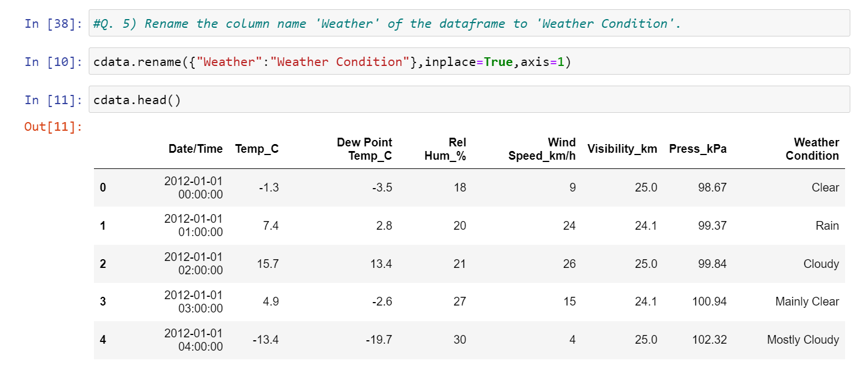

* We used rename() function to rename the column name to Weather to Weather Condition.

Q. 6) What is the mean 'Visibility'?

A. Below is the code to find mean for column visibility:

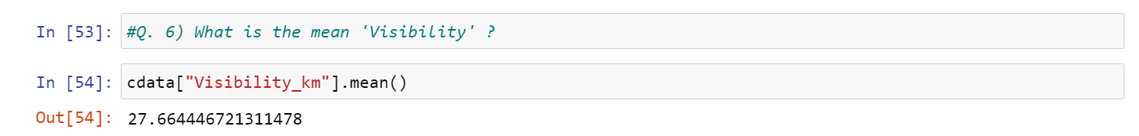

* First, we have to access visibility column. We used mean () function to get the mean visibility.
* From the data set, 27.6644467 is the mean for visibility column.

Q. 7) What is the Standard Deviation of 'Pressure' in this data?

A. Here is the code to find the Standard Deviation of column pressure in this data:

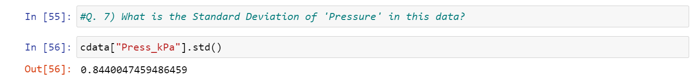

* First, we have to access pressure column. We used std () function to get the standard deviation of pressure.
* From the data set, 0.84400474 is the standard deviation for pressure column.

Q. 8) What is the Variance of 'Relative Humidity' in this data?

A. To find the variance of column relative humidity for the given data, Below is the code:

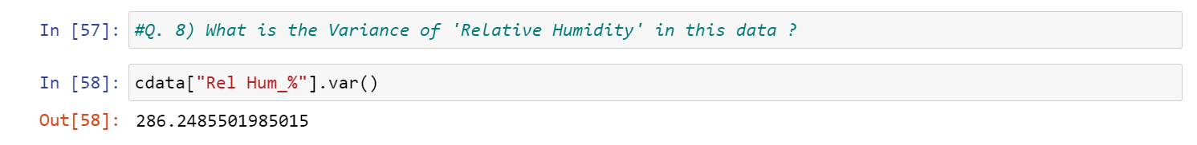

* First, we have to access relative humidity column. We used var () function to get the variance of relative humidity.
* From the data set, 286.2485501 is the variance for relative humidity column.

Q. 9) Find all instances when 'Snow' was recorded.

A. Here is the code to find all instances when snow was recorded:

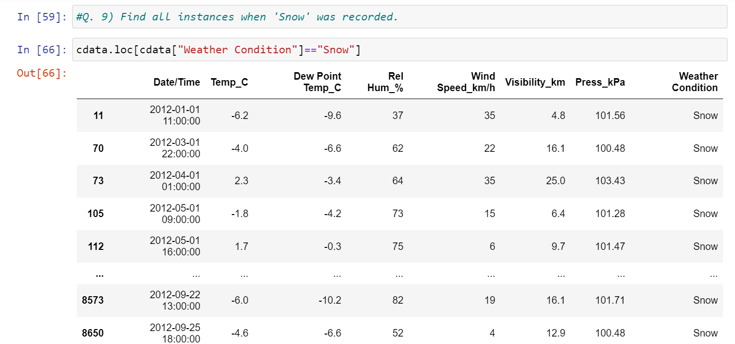

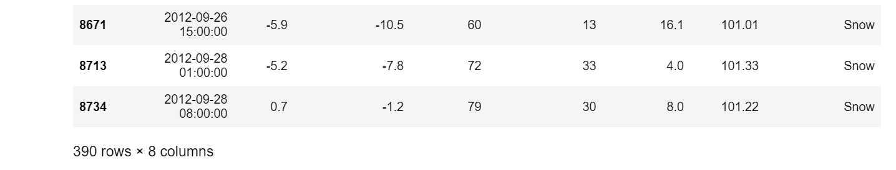

* By using loc function, we get the all instances when snow was recorded.
* Above output is the all instances when snow was recorded.

Q. 10) Find all instances when 'Wind Speed is above 24' and 'Visibility is 25'.

A. To find all instances when wind speed is above 24 and visibility is 25, below is the code:

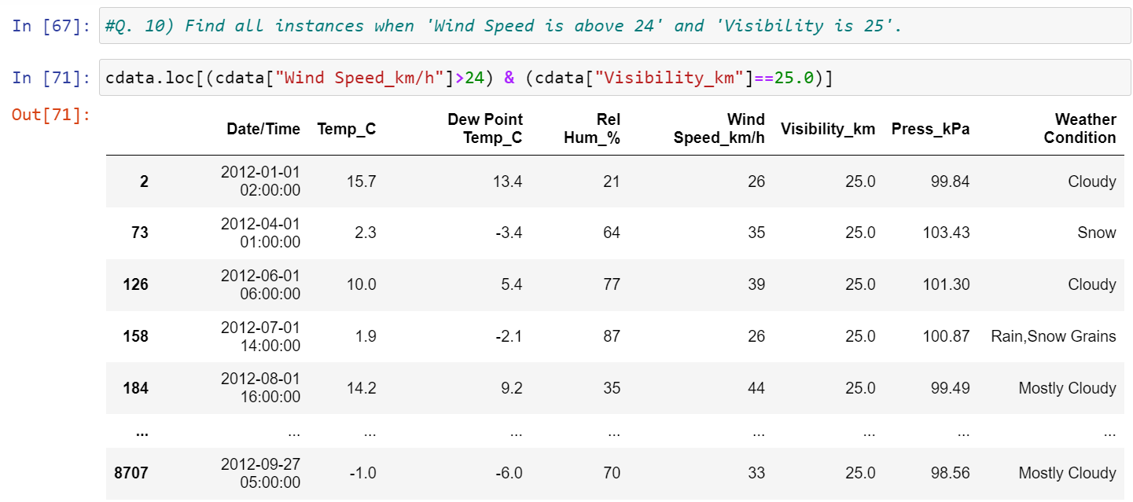

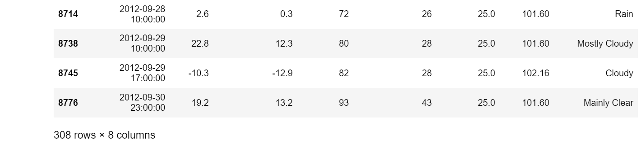

* By using loc function we get the all instances when wind speed is above 24 and visibility is 25.
* Above output is the all instances when wind speed is above 24 and visibility is 25 was recorded.

Q. 11) What is the Mean value of each column against each 'Weather Condition’?

A. To get the mean value of each column against each Weather Condition, below is the code:

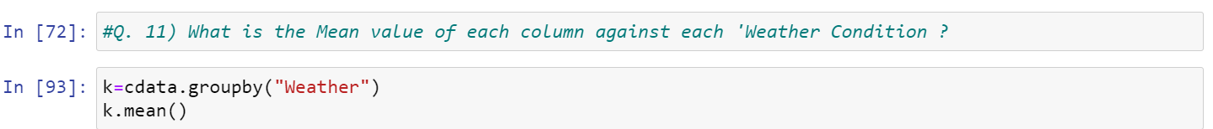

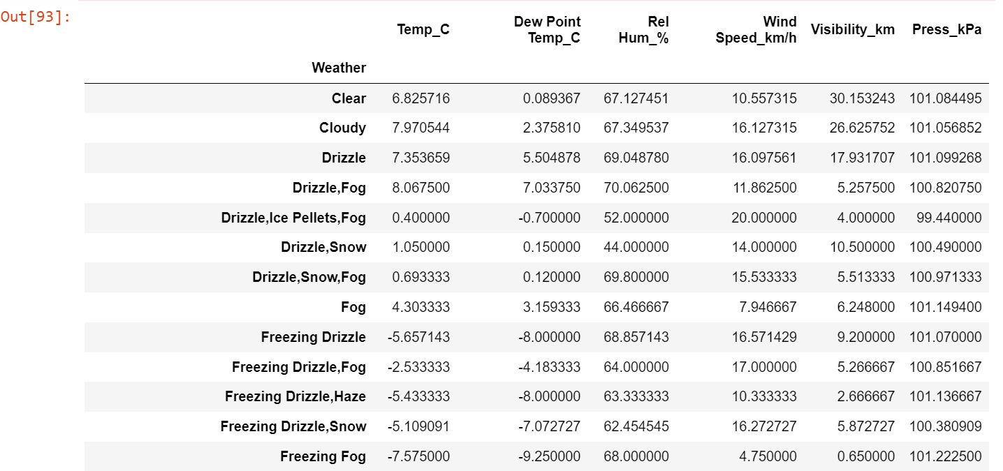

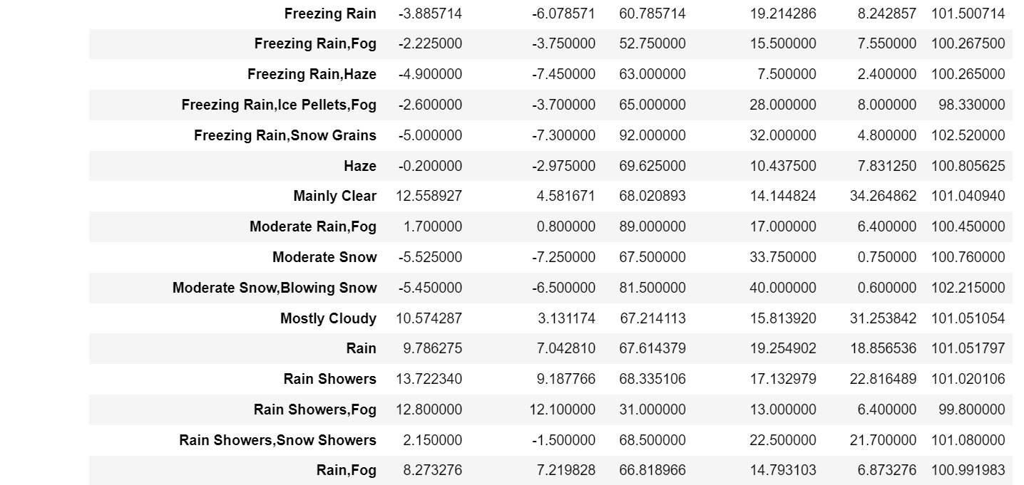

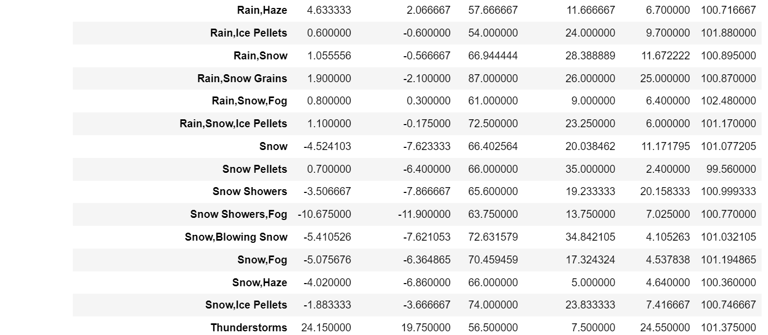

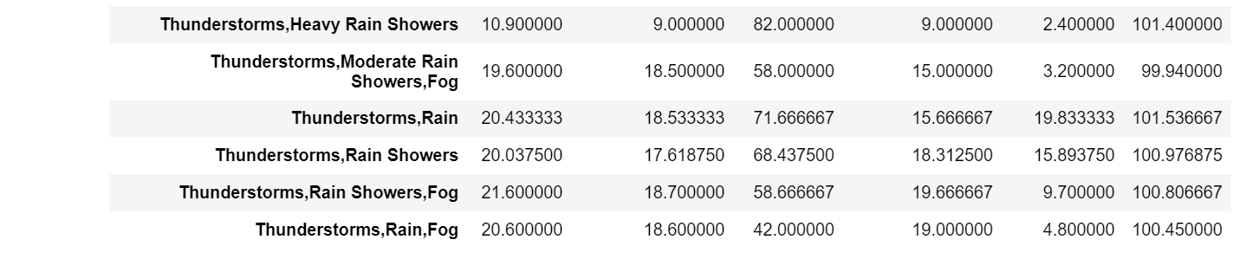

* By using groupby () function we divide weather column to groups. Using mean () function we get Mean value of each column against each Weather column.

Q. 12) What is the Minimum & Maximum value of each column against each 'Weather Condition’?

A. Here is the code to find the Minimum & Maximum value of each column against each Weather column: 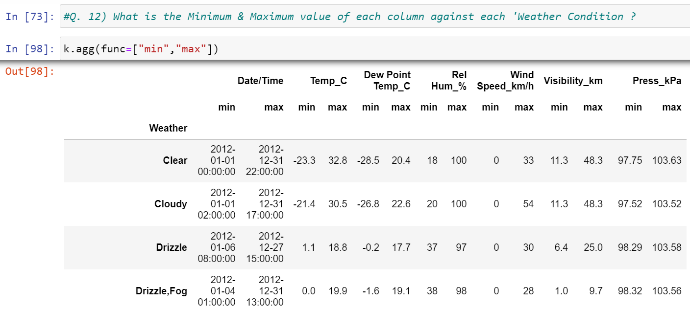

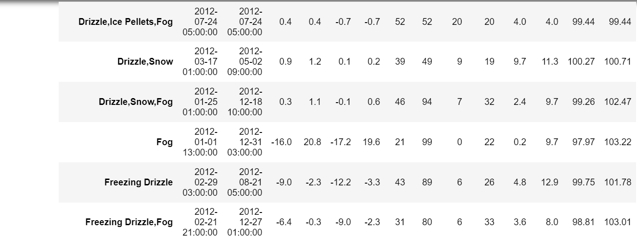

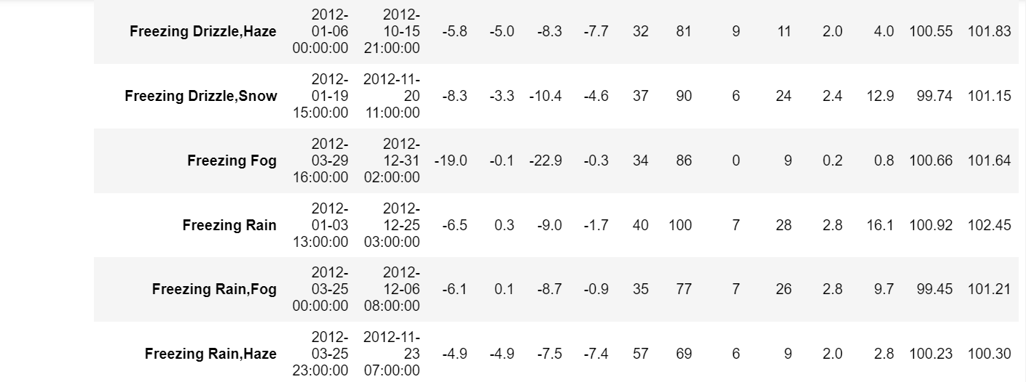

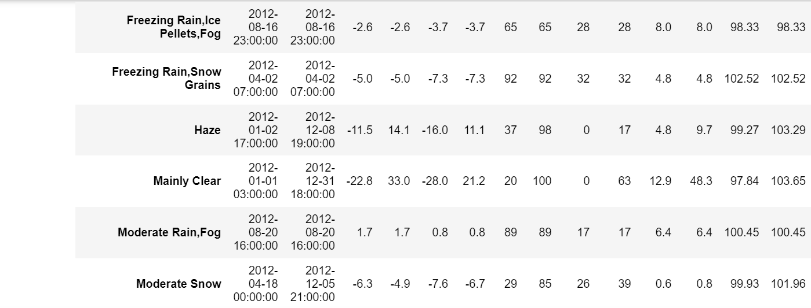

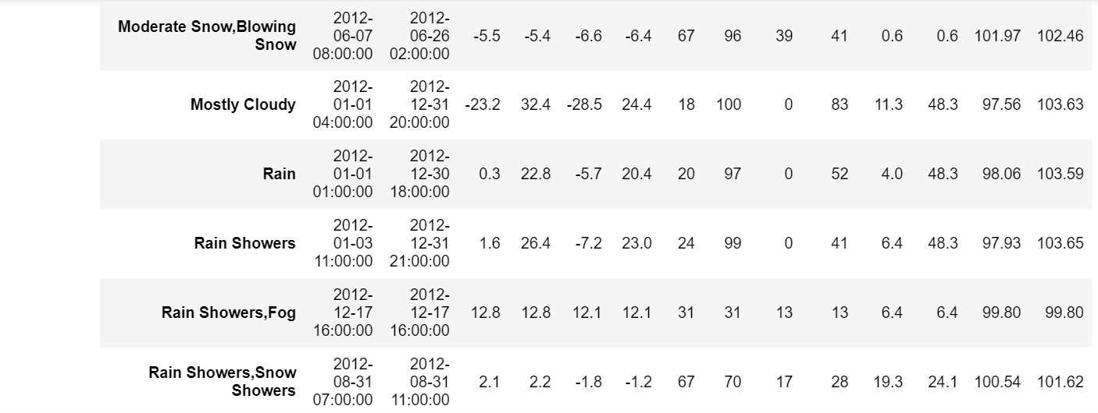

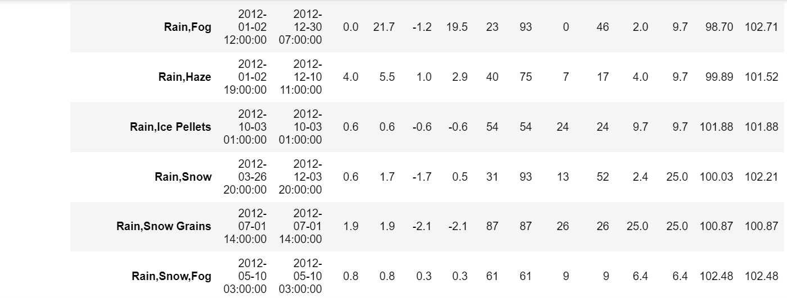

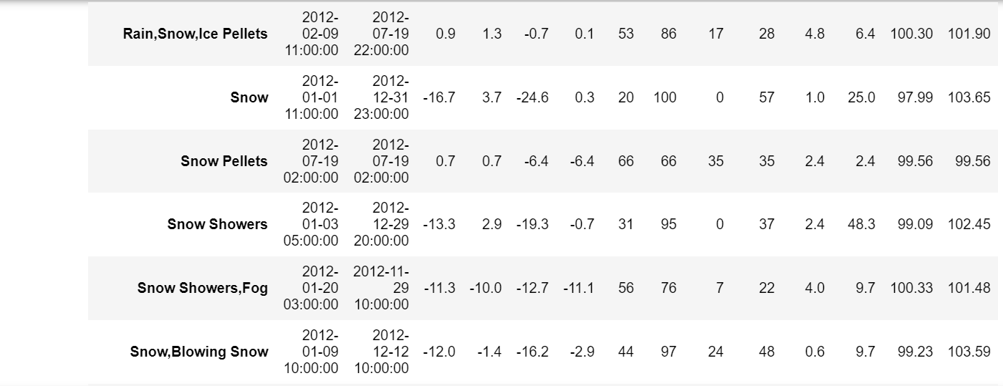

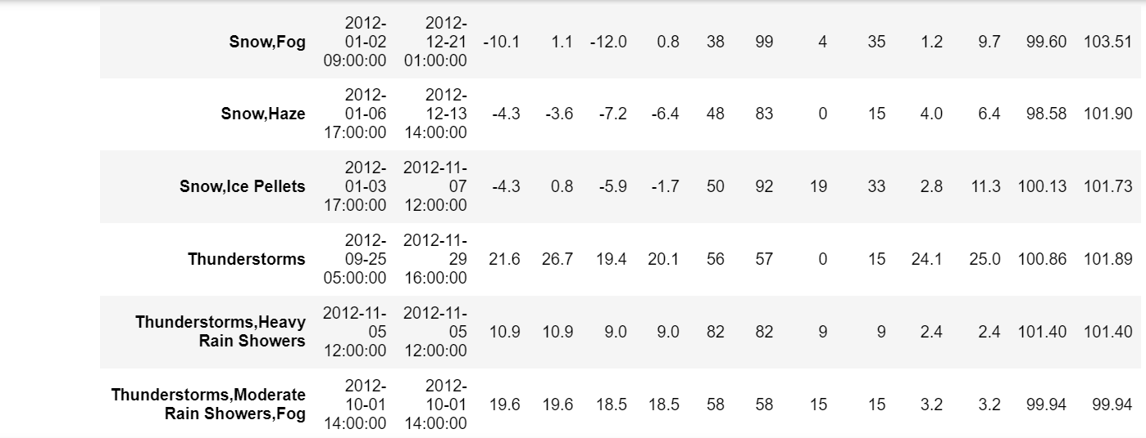

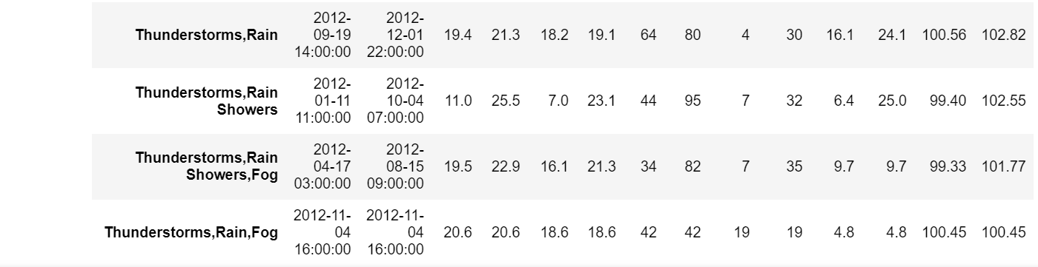

* By using groupby() function we divide weather column to groups. Using agg() function we get max and min value of each column against each Weather column.

Q. 13) Show all the Records where Weather Condition is Fog.

A. To find all the records where Weather Condition is Fog, below is the code:

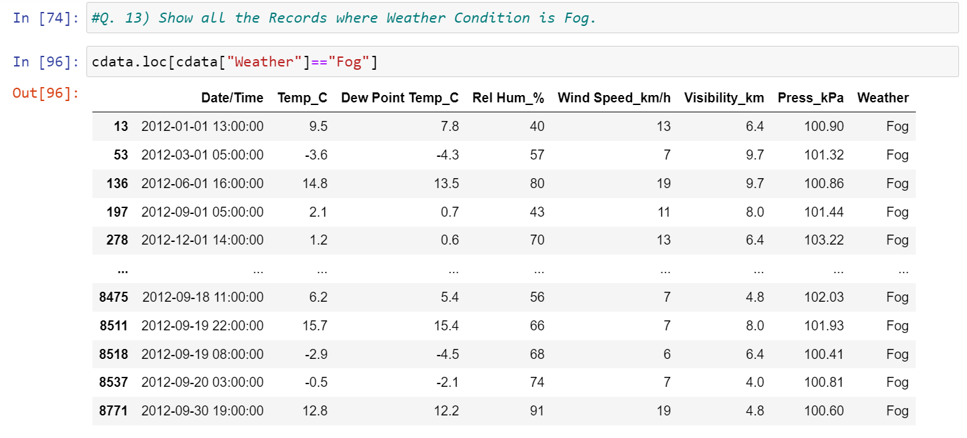

* By using loc function we get the records where Weather Condition is Fog.
* Above output is the all the records where Weather Condition is Fog.

Q. 14) Find all instances when 'Weather is Clear' or 'Visibility is above 40'.

A. To find all instances when Weather is Clear or 'Visibility is above 40, below is the code:

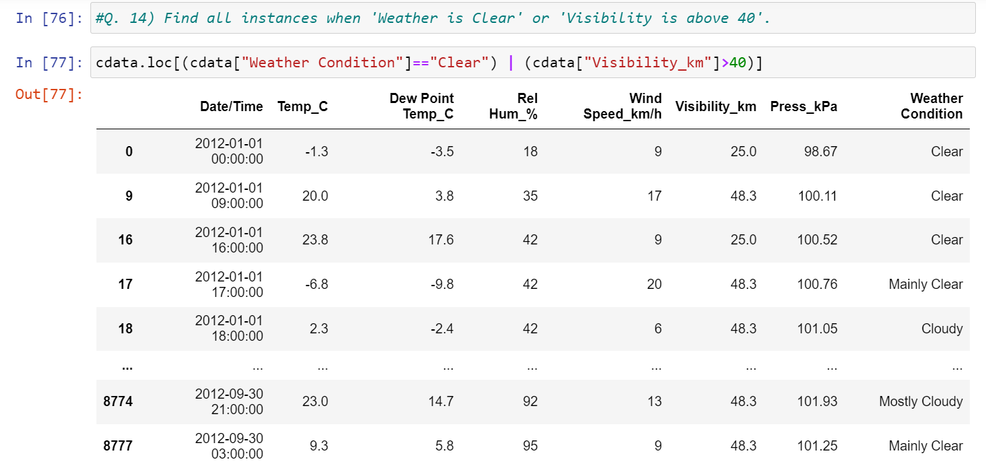

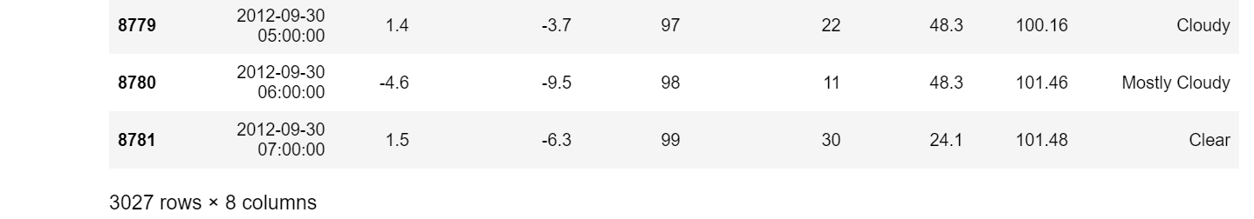

* By using loc function we get all instances when Weather is Clear or 'Visibility is above 40.
* Above output is the all the instances when Weather is Clear or 'Visibility is above 40.

Q. 15) Find all instances when:

A. 'Weather is Clear' and 'Relative Humidity is greater than 50'

or

B. 'Visibility is above 40'

A. To find all instances for above questions:

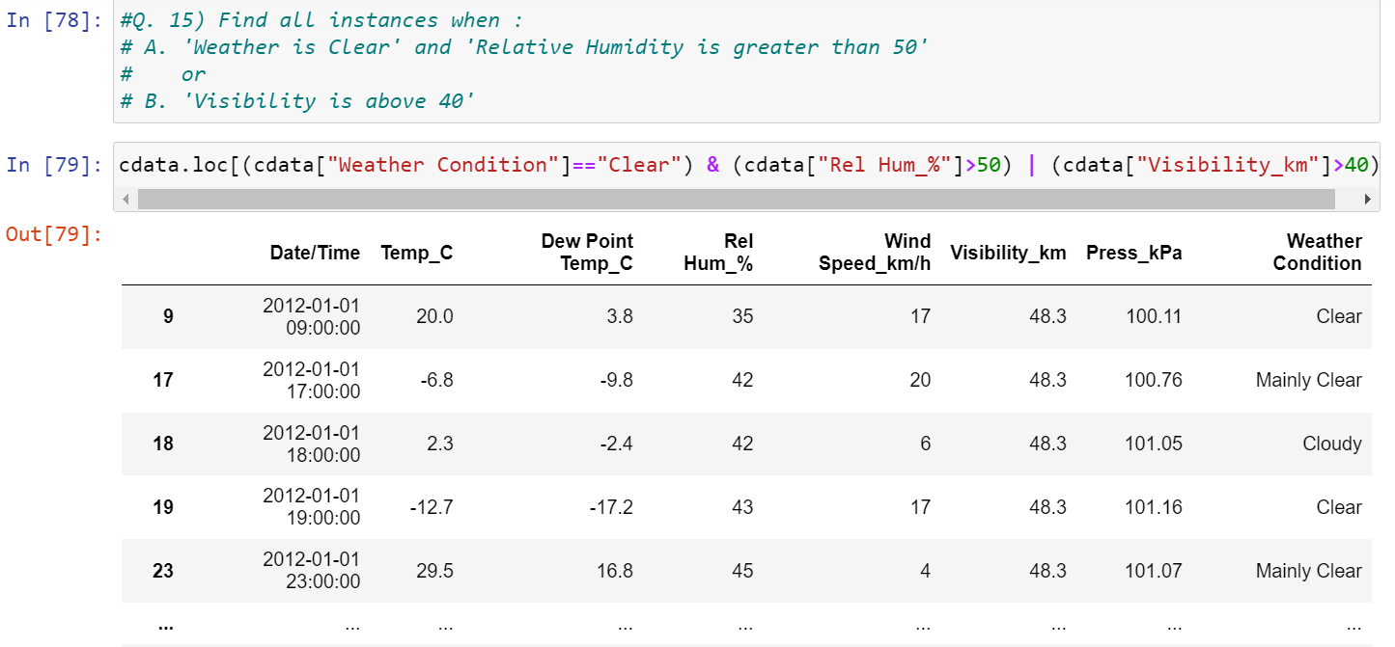

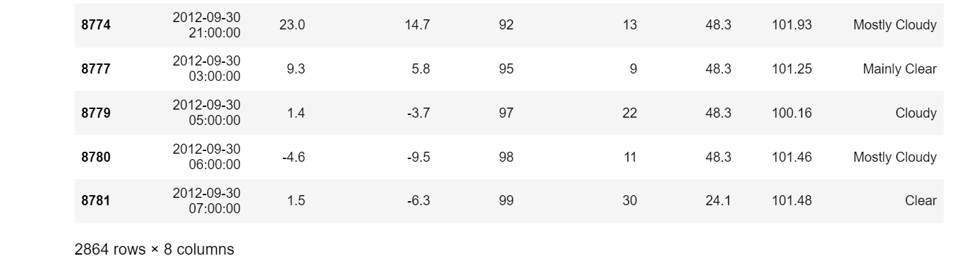

* By using loc function we get all instances for above questions.